Assignment operator and re-assignment

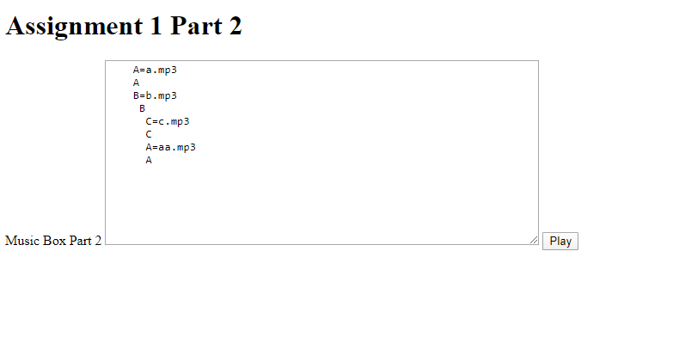

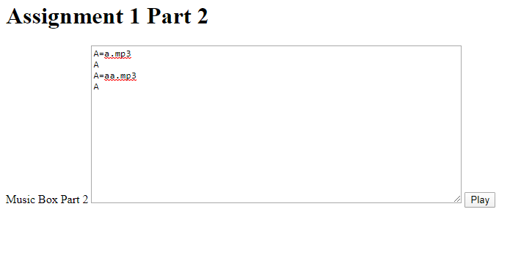

**Just in time assignment**

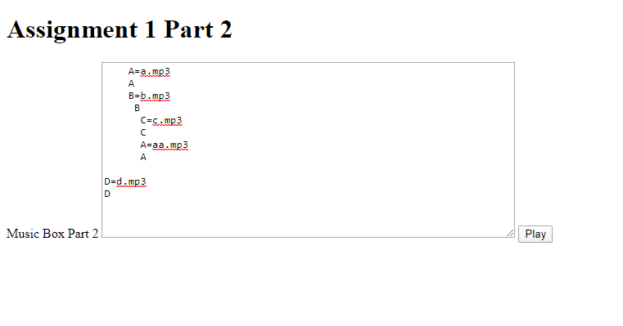

When you press play, no problem!

If user did not assign with sound, then a pop up message will take place

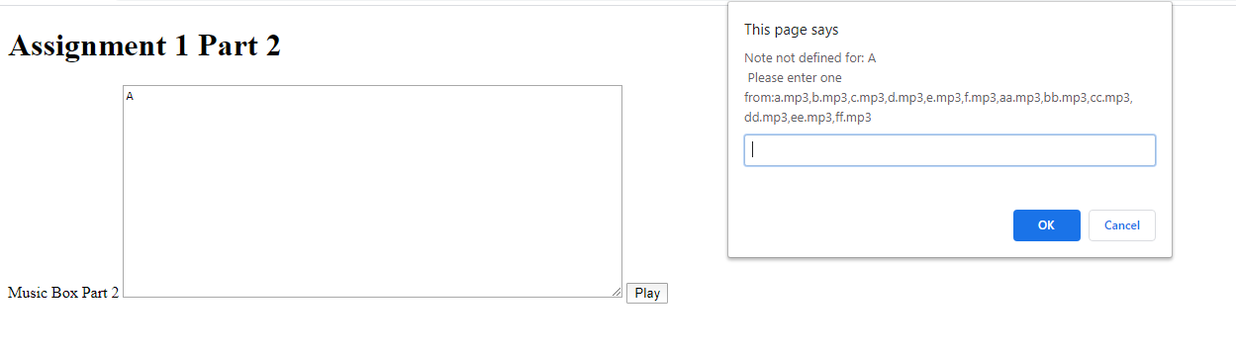

Type a.mp3 and press ok and it will play the a.mp3 sound

If a user type… Z

In our sound file, there is no z.mp3

User can choose whichever mp3 they want to play

